Reporting Statement

During the three years preceding the start date of the eHERITAGE project (01.11.2016), the coordinator team (UTBv) published the following articles in the specific field of virtual heritage:

- Girbacia, Florin, et al. "Virtual restoration of deteriorated religious heritage objects using augmented reality technologies." European Journal of Science and Theology 9.2 (2013): 223-231.

- Butnariu, Silviu, Florin Gîrbacia, and Alex Orman. "Methodology for 3D reconstruction of objects for teaching virtual restoration." International Journal of Computer Science 3.01 (2013): 16-21.

- Butnariu, Silviu, and Florin Gîrbacia. "High Quality 3D Restoration of Photographed Structures Using VR Technologies." Applied Mechanics and Materials 464 (2013): 391.

Date: Project coordinator:
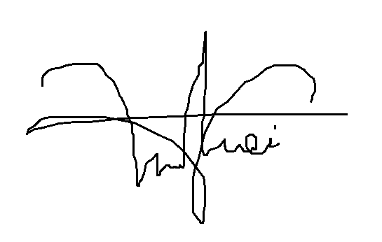
16.12.2015 PhD Eng Lecturer Mihai DUGULEANĂ

